docker compose version



docker compose up

**Tạo 1 file docker-compose.yml**

services:

web:

build: .

ports:

- "3000:3000"

depends_on:

- mongo

mongo:

image: mongo

ports:

- "27017:27017"

**Tạo file docker**

# Sử dụng image node chính thức

FROM node:18

# Tạo thư mục làm việc trong container

WORKDIR /app

# Copy file vào container

COPY package*.json ./

RUN npm install

COPY . .

# Cổng mà app sử dụng

EXPOSE 3000

# Lệnh chạy ứng dụng

CMD ["npm", "start"]

**Tạo package.json**

npm init -y

**Thực hiện**

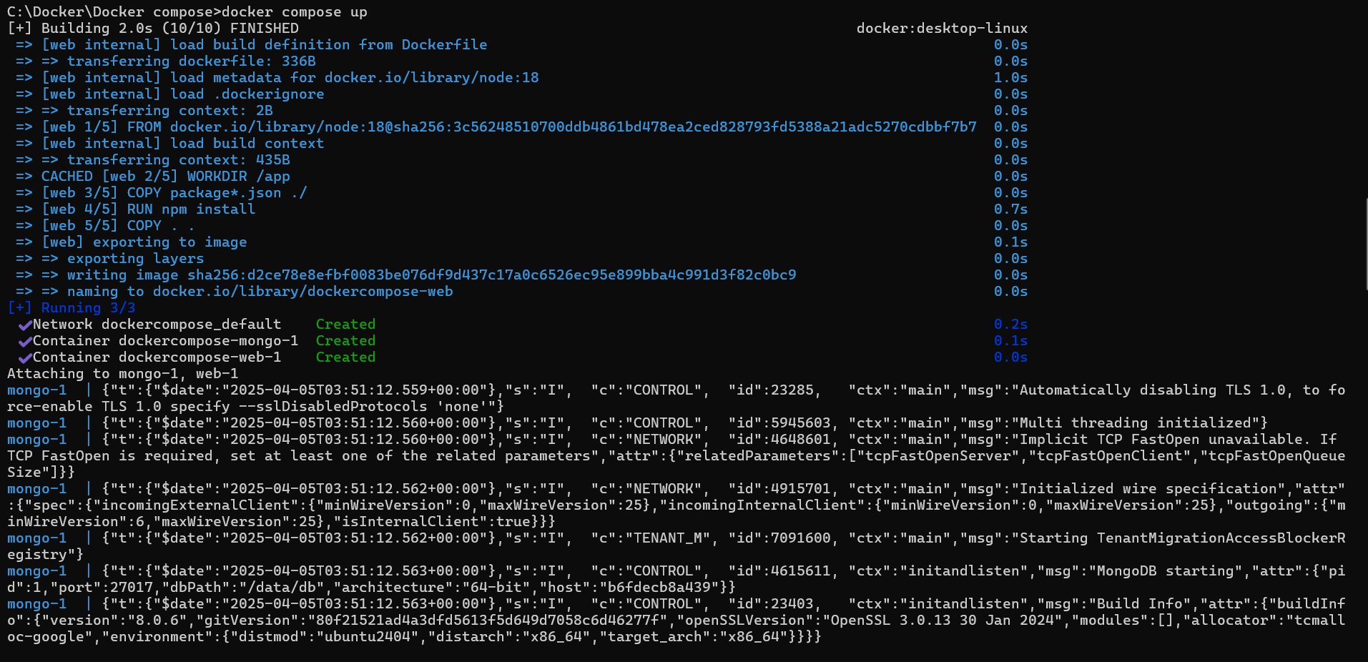

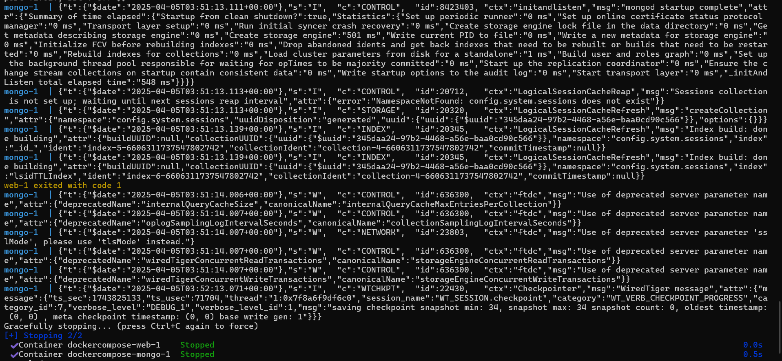

docker compose up -d



docker compose ps



docker compose down

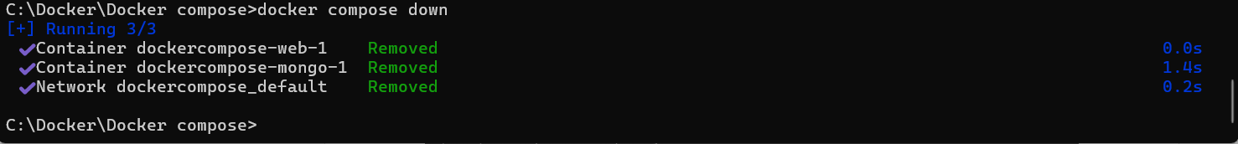

docker compose restart

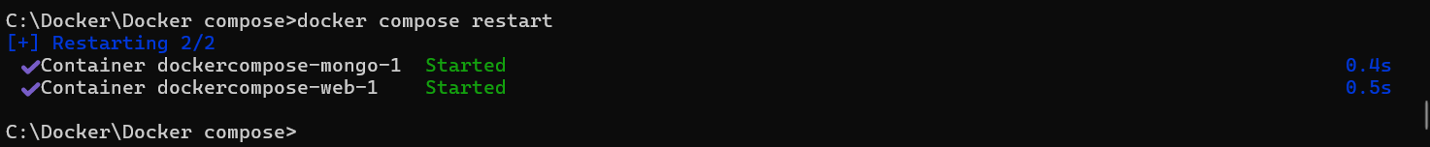

docker compose logs -f

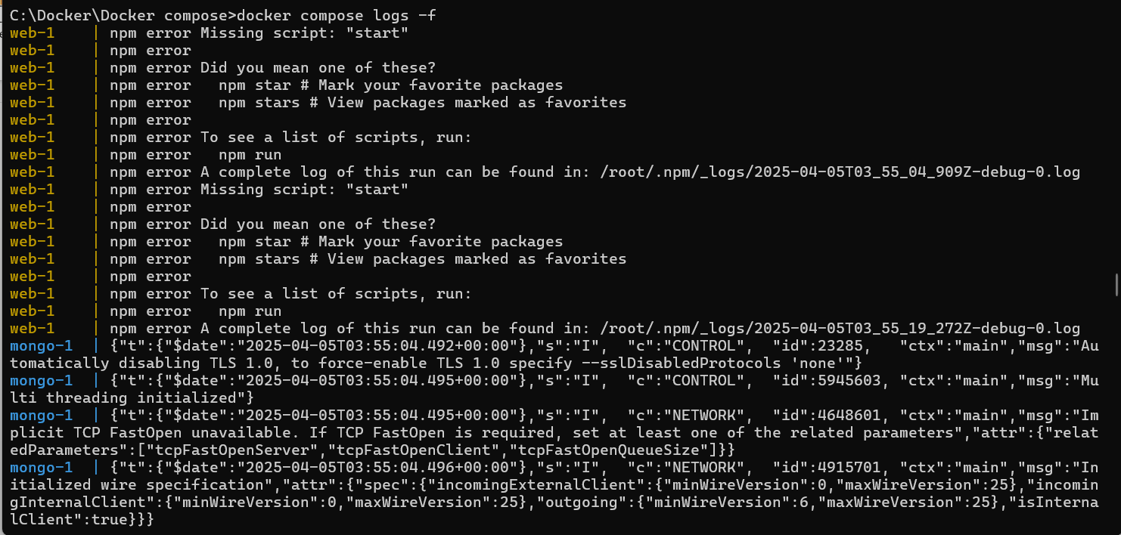

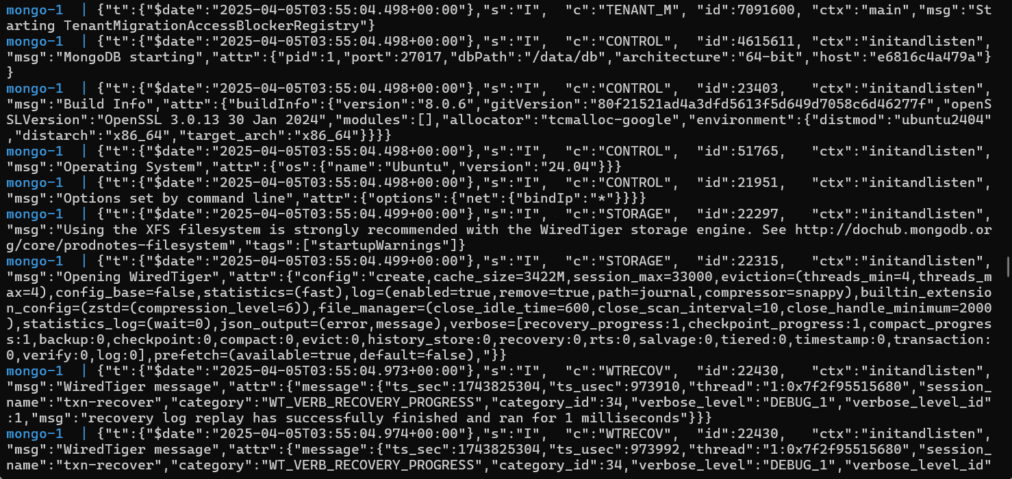

…

docker compose build

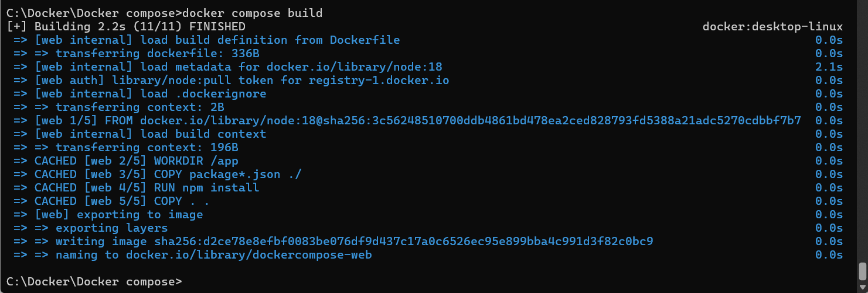

docker compose exec <service_name> <command>

**docker compose exec mongo mongosh**

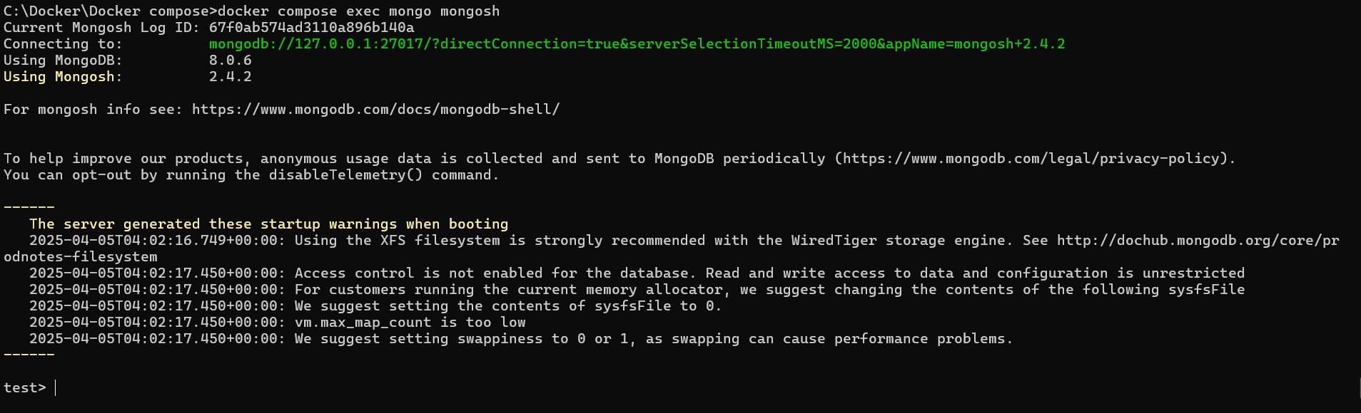

docker compose down -v

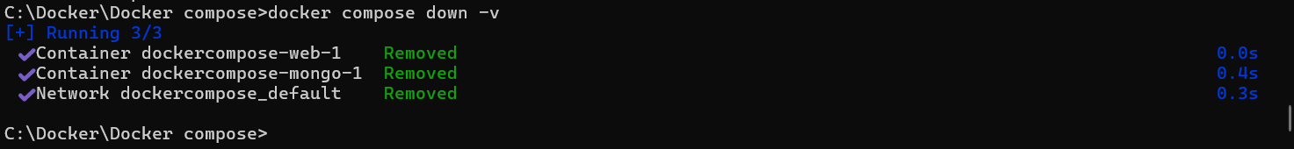

docker compose run <service_name> <command>

**docker compose run mongo mongosh**

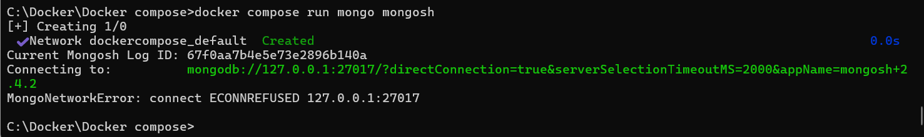

docker compose stop <service_name>

**docker compose stop mongo**



docker compose rm <service_name>

**docker compose rm mongo**



docker compose config

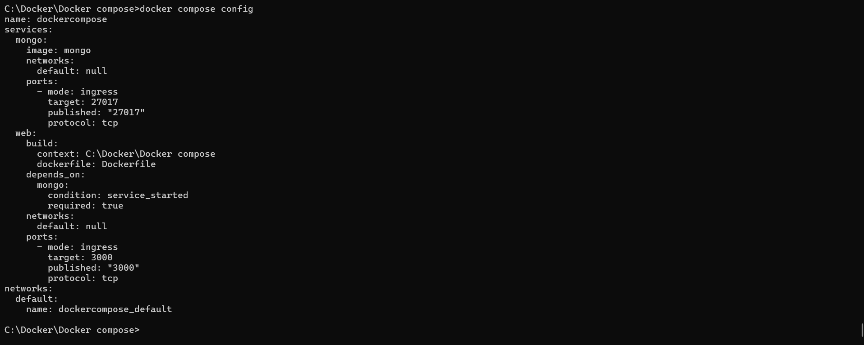

docker compose up -d --build

